*ISAD3000 Capstone Computing Project 1 Milestone 3 Group Report*

***Group E8: Amristar Industry Project [Virtual Jukebox]***

Group Members:

Austin Bevacqua, Bradley van der Zwan, Dillon Vincent,   
Ryan Webster, Tanaka Chitete

Table of Contents

***Capstone Milestone 3 Group Report*** ***2***

Study Contract **2**

Submitted Deliverables **3**

Agile Report **3**

Client/Supervisor Meetings 3

Group Meetings 4

Start/End of Sprint Meetings 4

Stand-up Meetings 4

Progress Tracking 4

Sprint 1 4

Sprint 2 5

Sprint 3 14

Reflection 16

Group Toggl Summaries 16

# ***Capstone Milestone 3 Group Report***

*Group E8: Amristar Industry Project [Virtual Jukebox]*

# Study Contract

See below for the study contract the group has created, and the semester 1 assessment and deliverables sheet provided by Amristar – the industry partner.

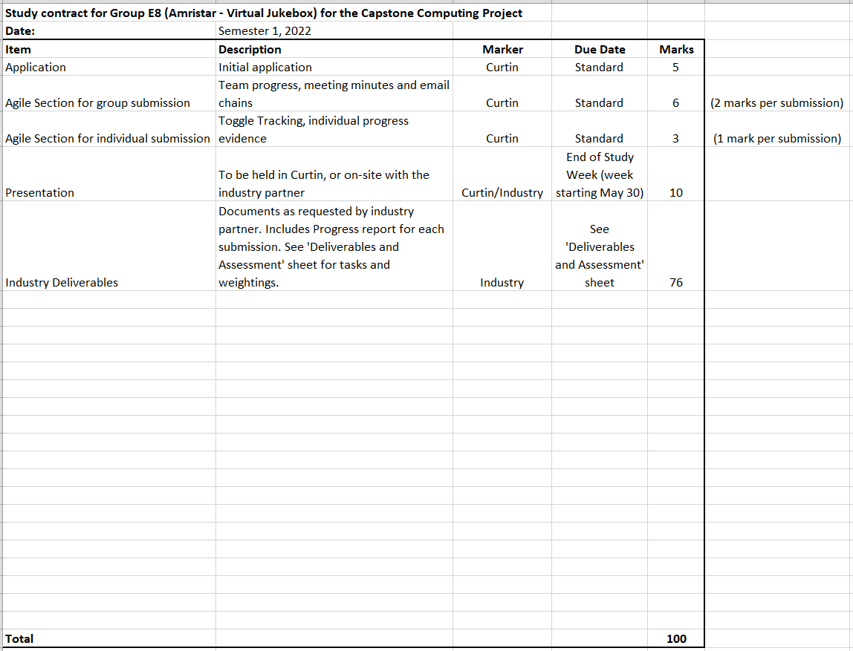

# Submitted Deliverables

The following link contains two submitted drafts of the technology investigation summary (TIS) & prototype deliverable for Amristar (v0.1, v0.2), as well as the final submission (v1.0).

<https://drive.google.com/drive/folders/1HRwxF2hvAp7NuhtgTB_6Otp_VpU6UqQa?usp=sharing>

The following link contains the Progress Report for the last reporting period, which was submitted to Amristar alongside the final TIS version.

<https://drive.google.com/drive/folders/17TZueRrJXqtCiXlrEAaZrLBKFdZHYLkt?usp=sharing>

# Agile Report

(Spans 26/03/2022 to 15/04/2022)

## Client/Supervisor Meetings

Both the client and the supervisor is Amristar. From 26/03/2022 to now (15/03/2022), the group has had three meetings with Amristar. The co-supervisor (or Curtin supervisor) is Senjian An.

In this reporting period, the three supervisor meetings were held on 28/03/2020, 4/04/2022, and 11/04/2022. No meetings were held with the Curtin supervisor.  
  
See below for a link to the group folder storing the meeting minutes taken at each of these meetings.

Supervisor meeting minutes’ link: <https://drive.google.com/drive/folders/1rKsgHWpck5Wpd935lpXTCyADSaPFoQgS?usp=sharing>

Several email chains were developed in communication with the supervisor(s) to arrange these meetings and to send them the minutes after they ended. See below for a link to the group folder containing these email chains, as well as emails of group-meeting minutes sent to the co-supervisor, and other important emails sent to and from supervisors.

Supervisor email chains link: <https://drive.google.com/drive/folders/1m3V6q4Ag1tA2nr3dUpKpSFSrxENQMVbv?usp=sharing>

## Group Meetings

Group meeting minutes link: <https://drive.google.com/drive/folders/1OImhOwUw_PIgKJ7r6JA-oma24w2zfaJa?usp=sharing>

### Start/End of Sprint Meetings

From the time-frame of the last reporting period to now, there have been a total of two sprint planning meetings (for sprint 2 and 3), and two sprint retrospective meetings (for sprints 1 and 2) held amongst the team.

Sprint 2’s planning meeting was held online on 29/03/2022, and sprint 3’s planning meeting was held online on 13/04/2022. During each of these meetings, plans for activities to be undertaken for the respective sprints were discussed, with the team’s JIRA page being updated accordingly.

Sprint 1’s retrospective meeting was held online on 30/03/2022, and sprint 2’s was held online on 13/04/2022. Each of these meetings consisted of creating action items based on what could be improved upon that sprint, as well as considering which aspects went well. See the minutes of these meetings for reflections on those sprints recorded during those meetings.

### Stand-up Meetings

There have been a total of five stand-up meetings during this reporting period, each of which involved discussions of individual member progress and issues.

In sprint 1, a stand-up was held on 26/03/2022. For sprint 2, stand-ups were held on 31/03/2022, 3/04/2022, 5/04/2022, and 8/04/2022. See the minutes of these meetings for discussions on individual progress on a three-day basis.

## Progress Tracking

### Sprint 1

Sprint 1 has finished (29/04/2022). During this sprint, research was completed for each team member’s assigned technology:

* Austin and Dillon: Front-end and Back-end frameworks
* Bradley: Database systems
* Tanaka: Music streaming SDKs and APIs
* Ryan: Real-time messaging systems, and back-end integration with messaging systems.

Each member compiled a separate document of research to be combined into a single technology investigation summary report. Although no major tasks were completed, the majority of the research per technology was done this sprint. The first draft of this was not compiled and submitted until sprint 2.

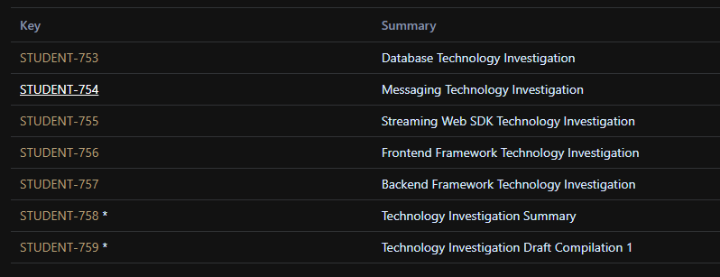

### Sprint 2

Sprint 2 has finished (12/04/2022), and involved the completion and submission of two TIS drafts, which were used to gather feedback from Amristar to fine-tune the final submission, which was also undergone. Additionally, small prototypes were developed to test the proposed technologies and gain familiarity with them. A progress report was also completed (via a provided template) which outlined the team’s contributions and issues to the deliverable.

The following sprint report outlines all tasks completed, and not completed during sprint 2.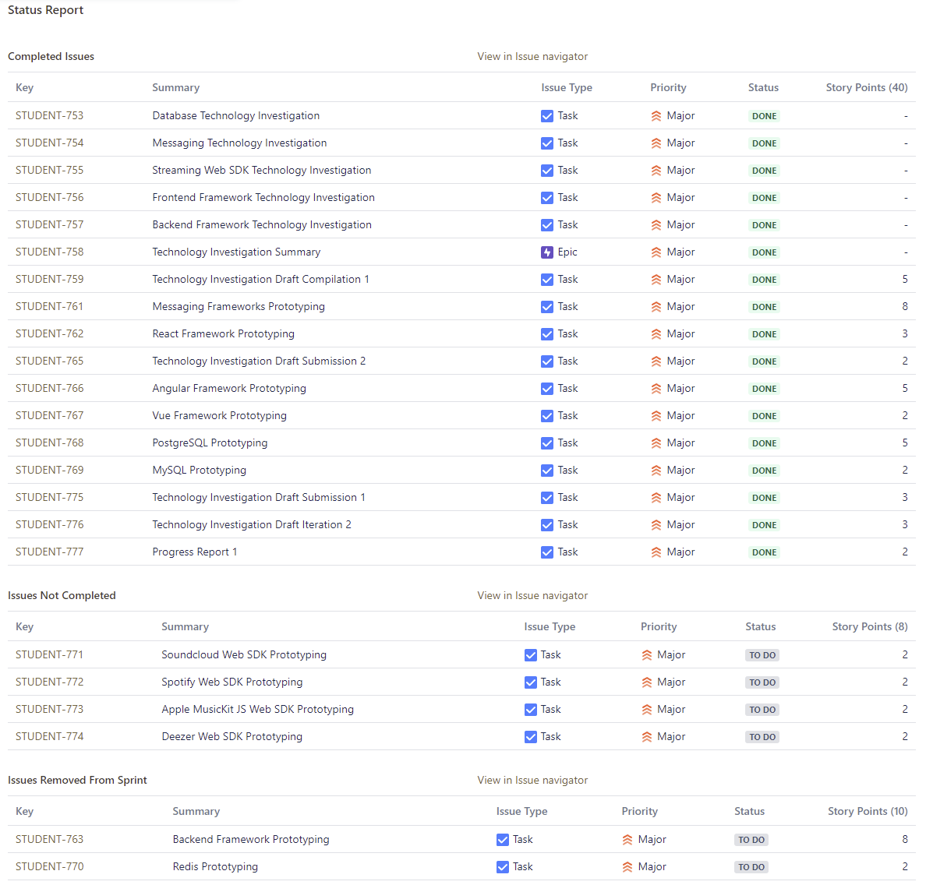

Although prototyping was not entirely completed, they were not required for the TIS submission, and simply aim to provide personal familiarity of the technologies per team-member.

The following burnup and burndown chart showcase the sprint’s completed work in comparison to its scope:

**Burnup Chart**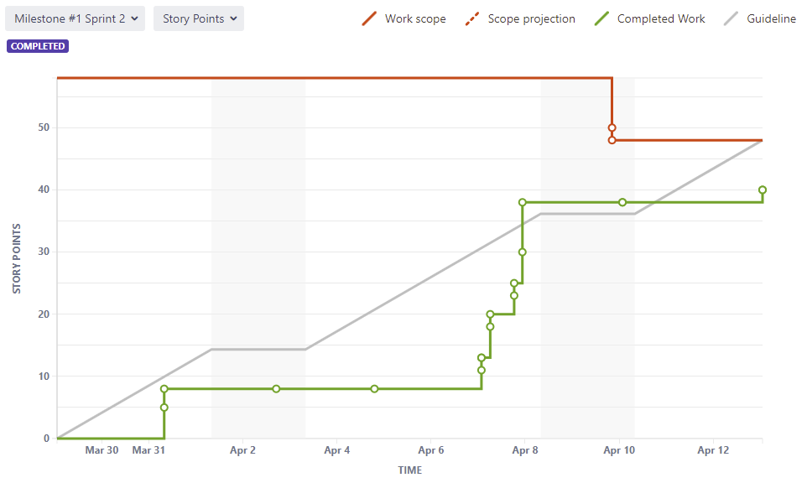

**Burndown Chart**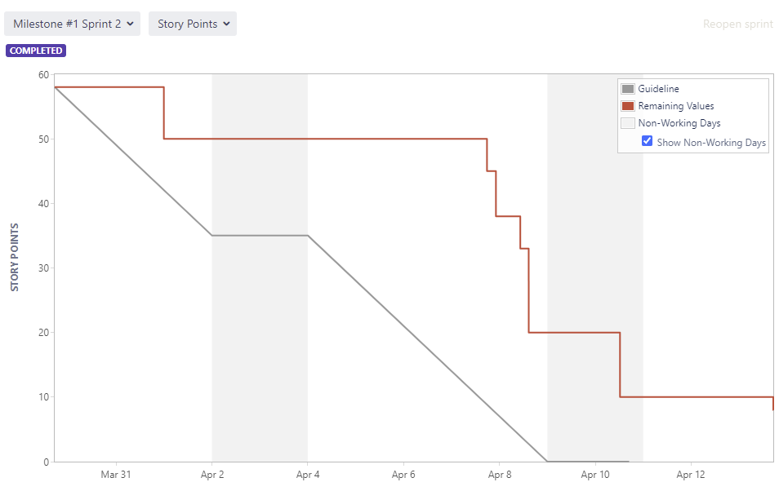

The following list outlines the achievements per person in sprint 2, as well as any other responsibilities they possess (see individual submissions for more detail and time spent):

* *Austin Bevacqua:*
  + As scrum master, was in charge of ensuring the group was following the agile process. Made sure the group was keeping Jira up to date, and every member was sticking to their assigned tickets.
  + Added all tickets to Jira with names, and allocated people their tickets.
  + Organised and ran sprint kickoff, retrospective and standup meetings.
  + Contributed to the frontend and backend portions of the TIS draft 1, draft 2, and final submission.
  + Finished frontend and backend database research, researching 10 frontend solutions and 8 backend solutions
  + Completed prototyping for the Vue and React frameworks.
  + Decided on a final frontend solution of Vue and a final backend solution of Django, and justified this decision in the TIS.
  + Added personal contributions to the progress report and milestone 3 group report.

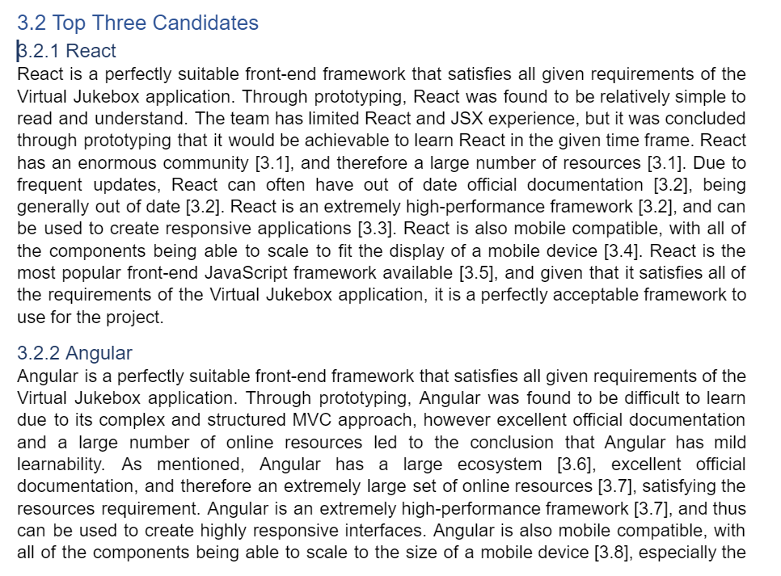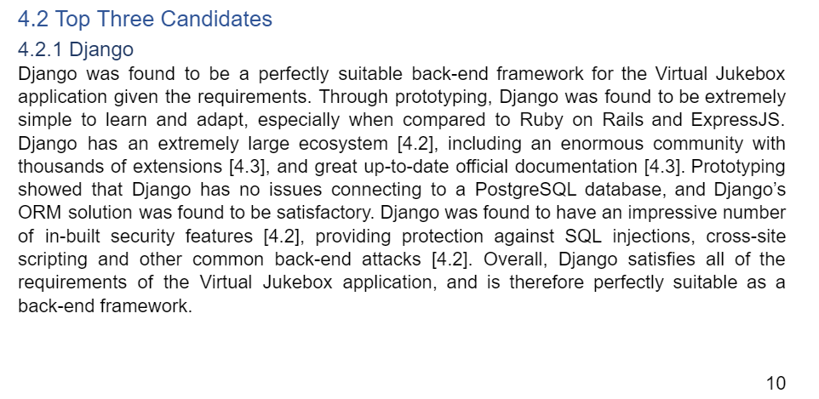

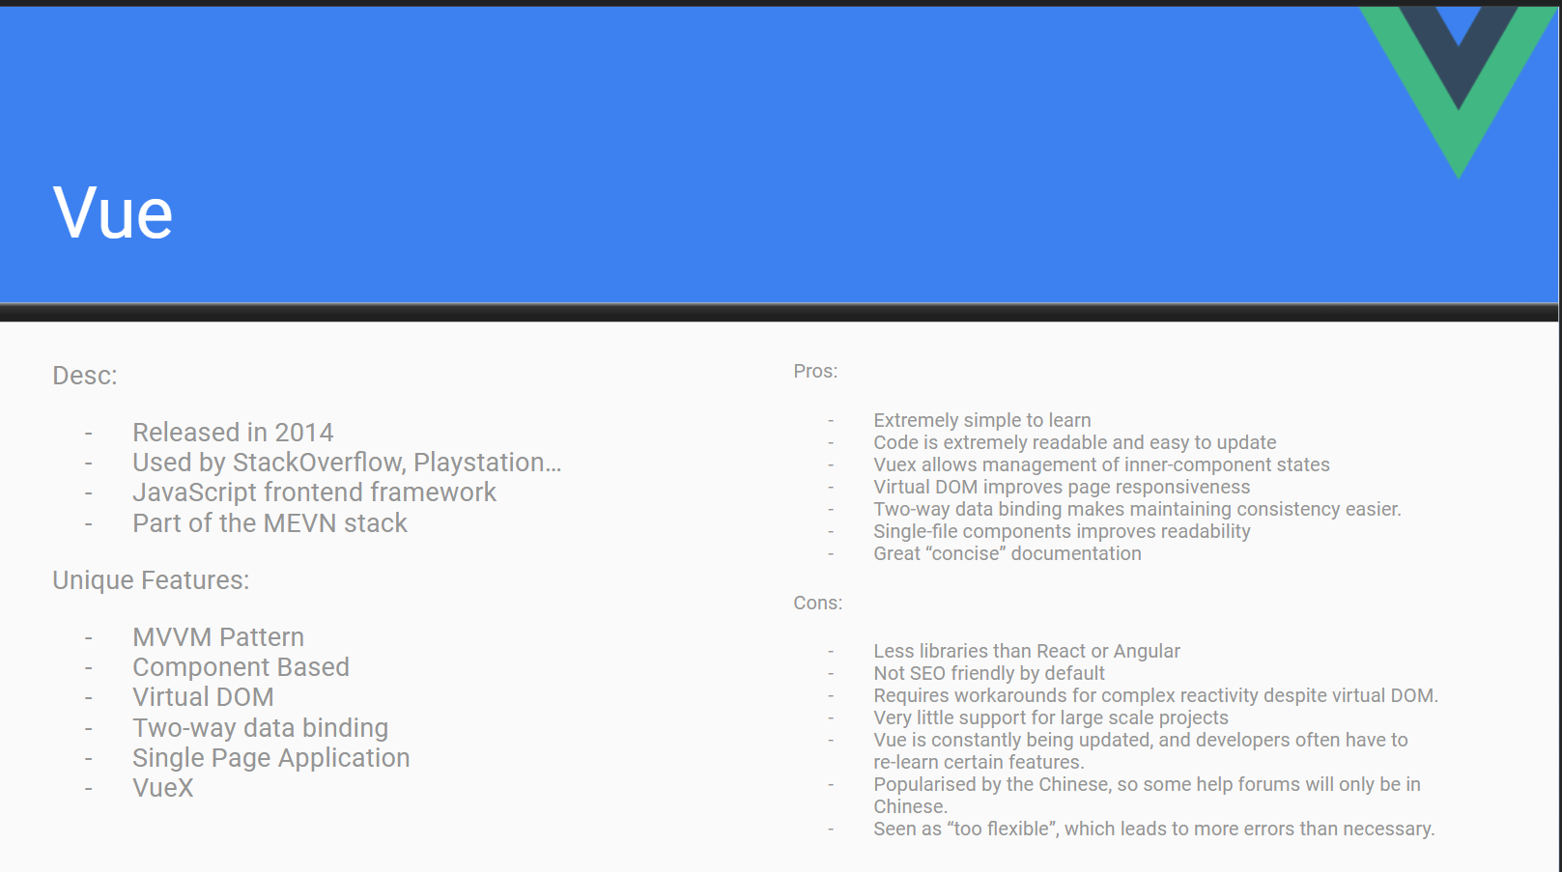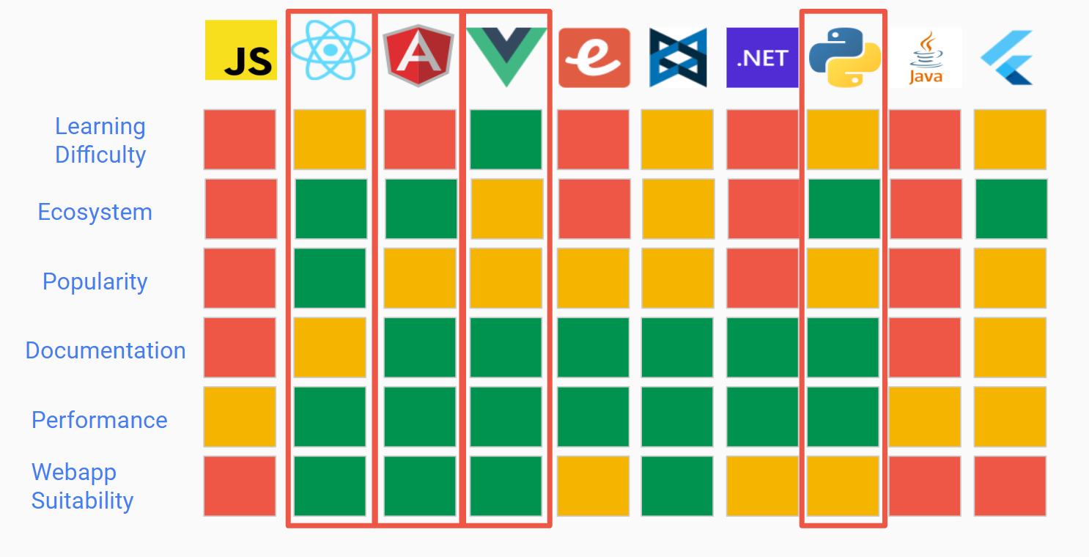

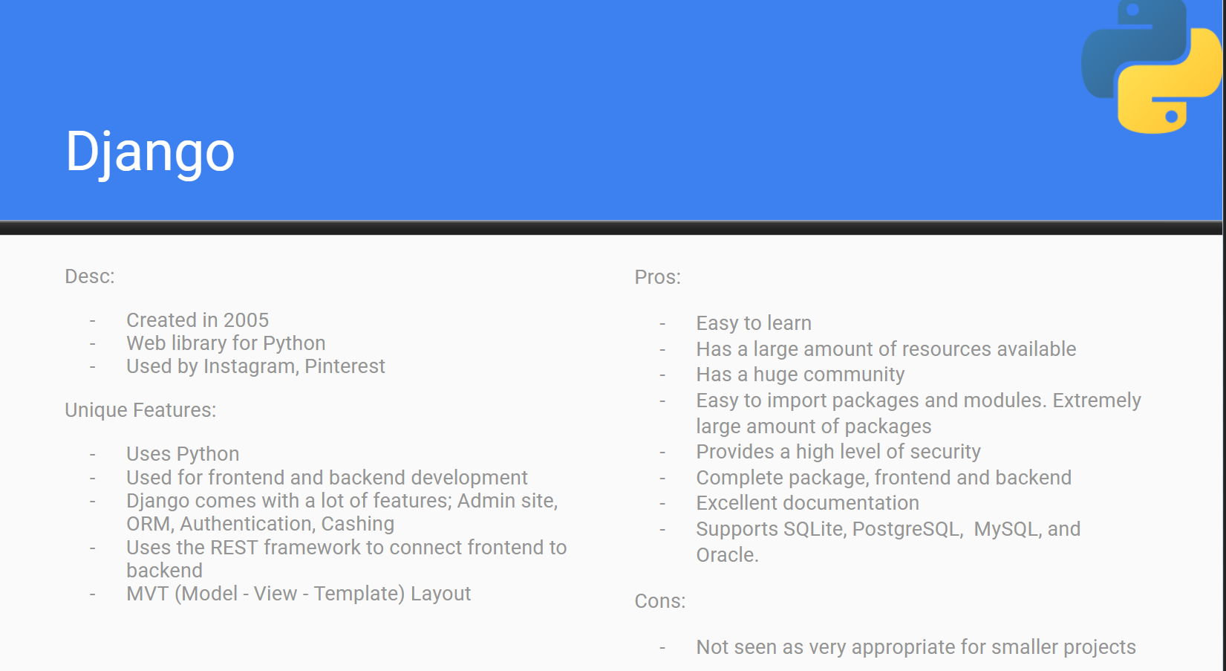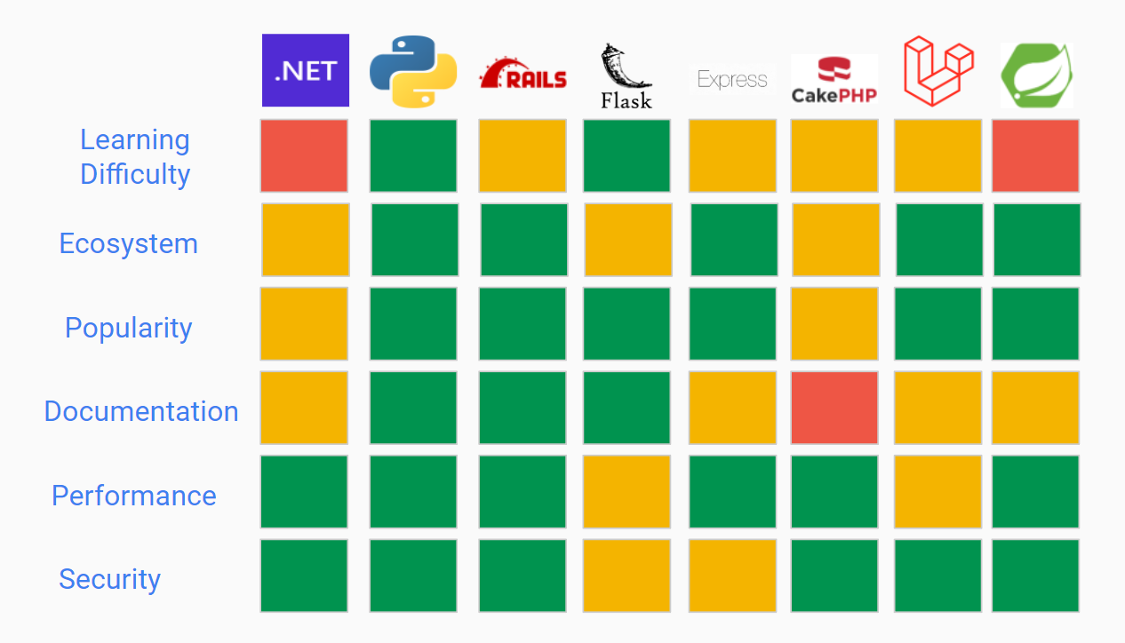

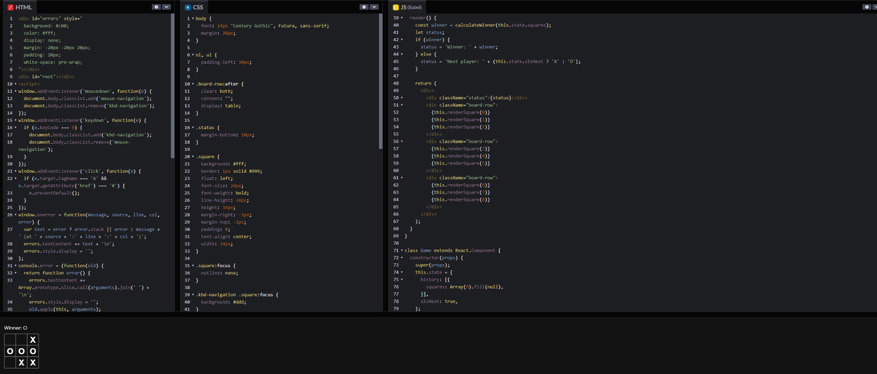

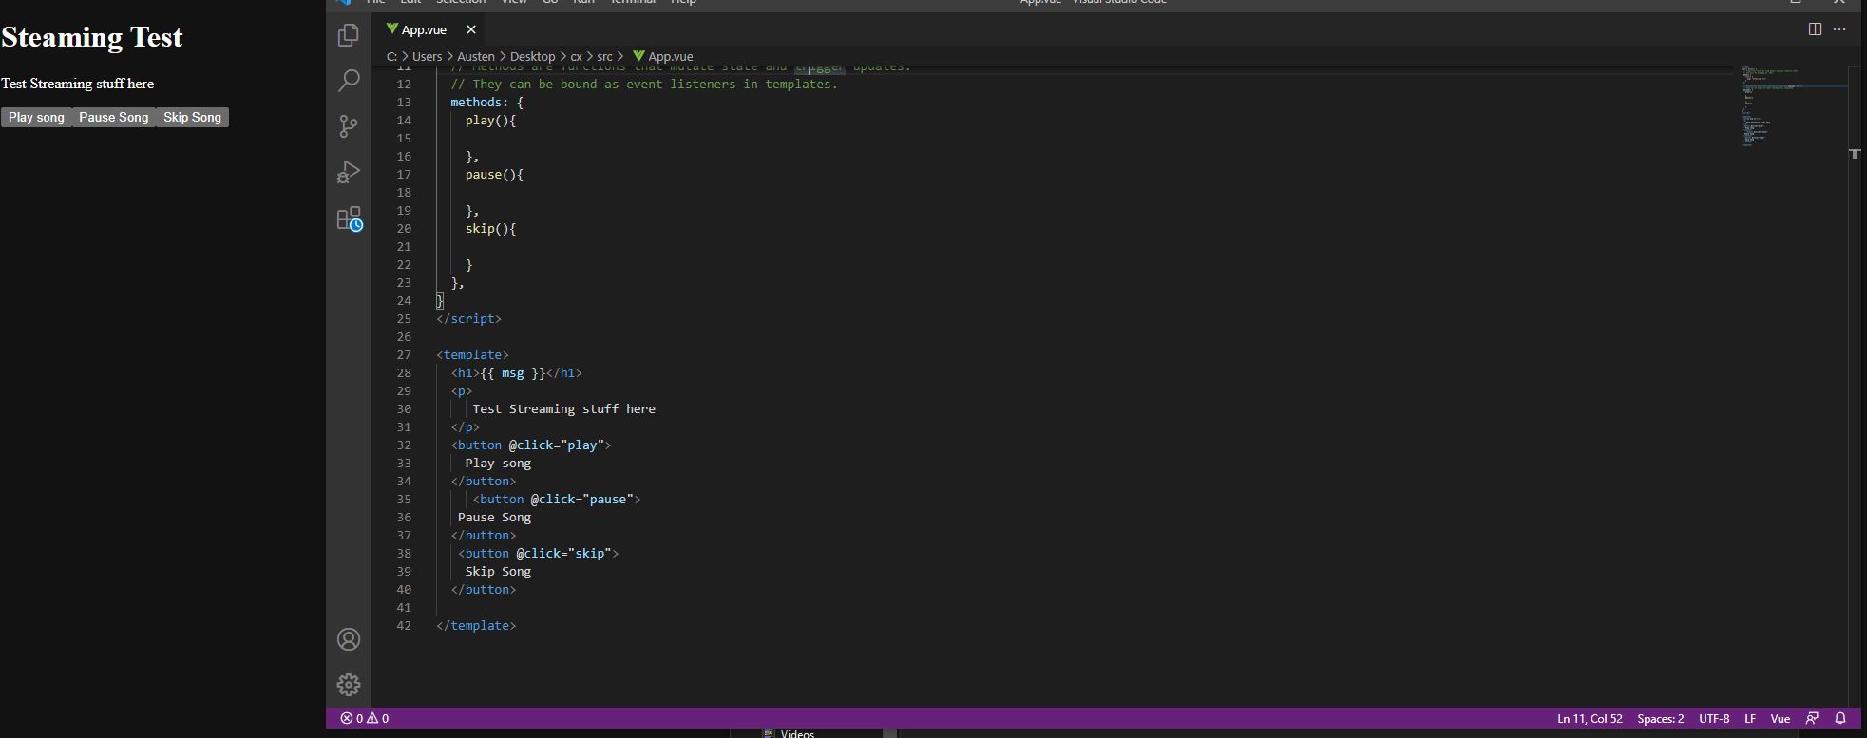

* *Bradley van der Zwan:* 
  + Contributed to the database systems portions of the TIS draft 1, draft 2, and final submission.
  + Finished database research relevant to the TIS this sprint.
  + Prototyped pure SQL sample databases of both MySQL and PostgreSQL, then prototyped database ORM implementations in TypeORM and Django ORM.
  + In the TIS Draft 1, compared 8 different database systems, whereas in draft 2, the content was refined down to just 3 database systems (MySQL, Redis, PostgreSQL) that were suitable for the final product, and content was trimmed and reformatted to align with a consistent report design. Also included comparisons between 3 Node.js ORMs (TypeORM, Prisma, Sequelize), and 2 Python ORMs (Django ORM, and SQLAlchemy). The following screenshots outline evidence of these ORM and database comparisons (see TIS report section 5 for full contribution and comparison):

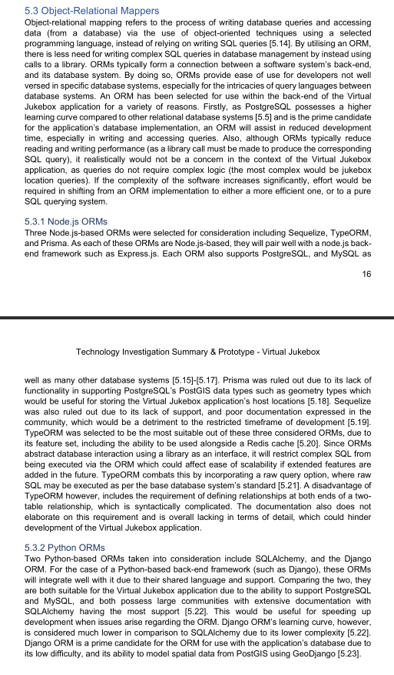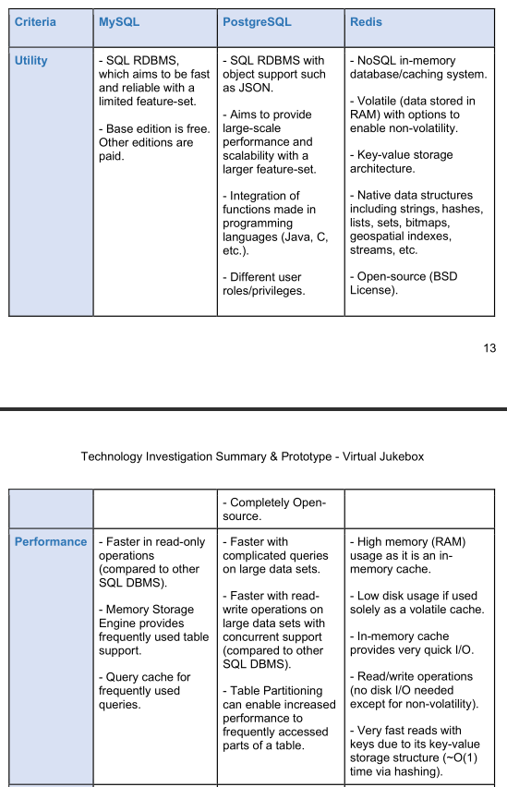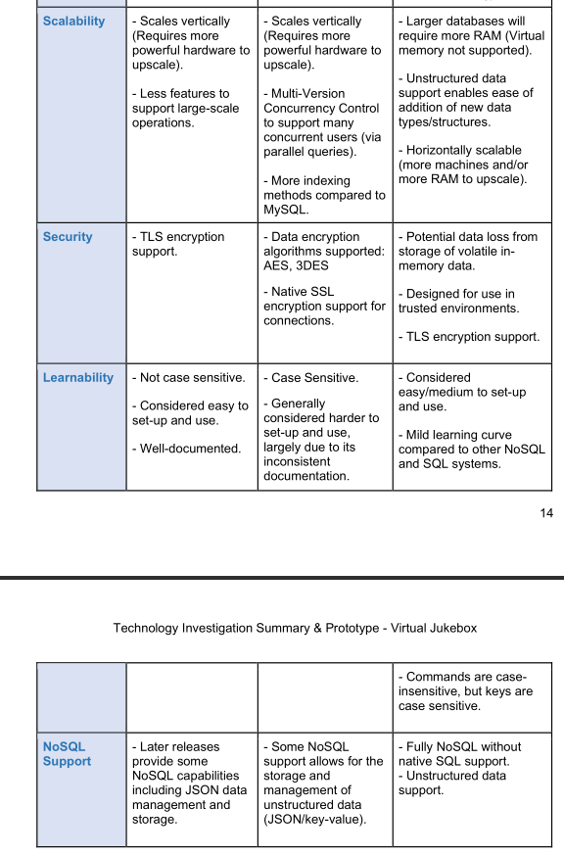

* + Decided on usage of a PostgreSQL database with interaction via the Django ORM alongside a Redis on-memory store for caching. The following screenshots are code of a sample prototype of the Django ORM implementation on a sample database: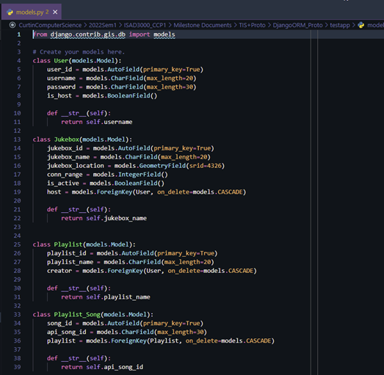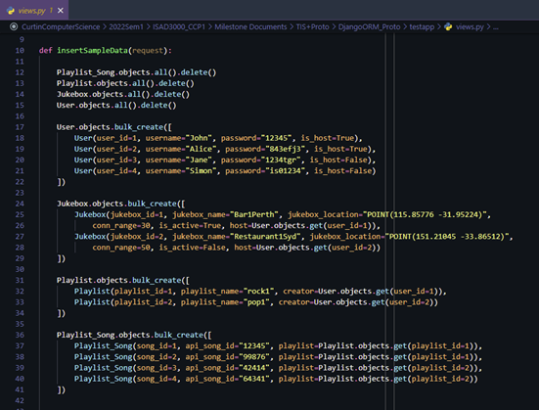
  + Added personal contributions and cumulative time-spent as a team to the progress report.
  + Responsible for all meeting minutes, email compilations into the shared drive, and submissions of TIS drafts 1 and 2.
  + Additionally responsible for putting together the milestone 3 group report and its submission (although this was done in sprint 3).
* *Dillon Vincent:*
  + Researched front-end and back-end frameworks with Austin
  + Took information from the previous sprint and wrote the drafts
  + Worked on section 3 and 4 in the TIS

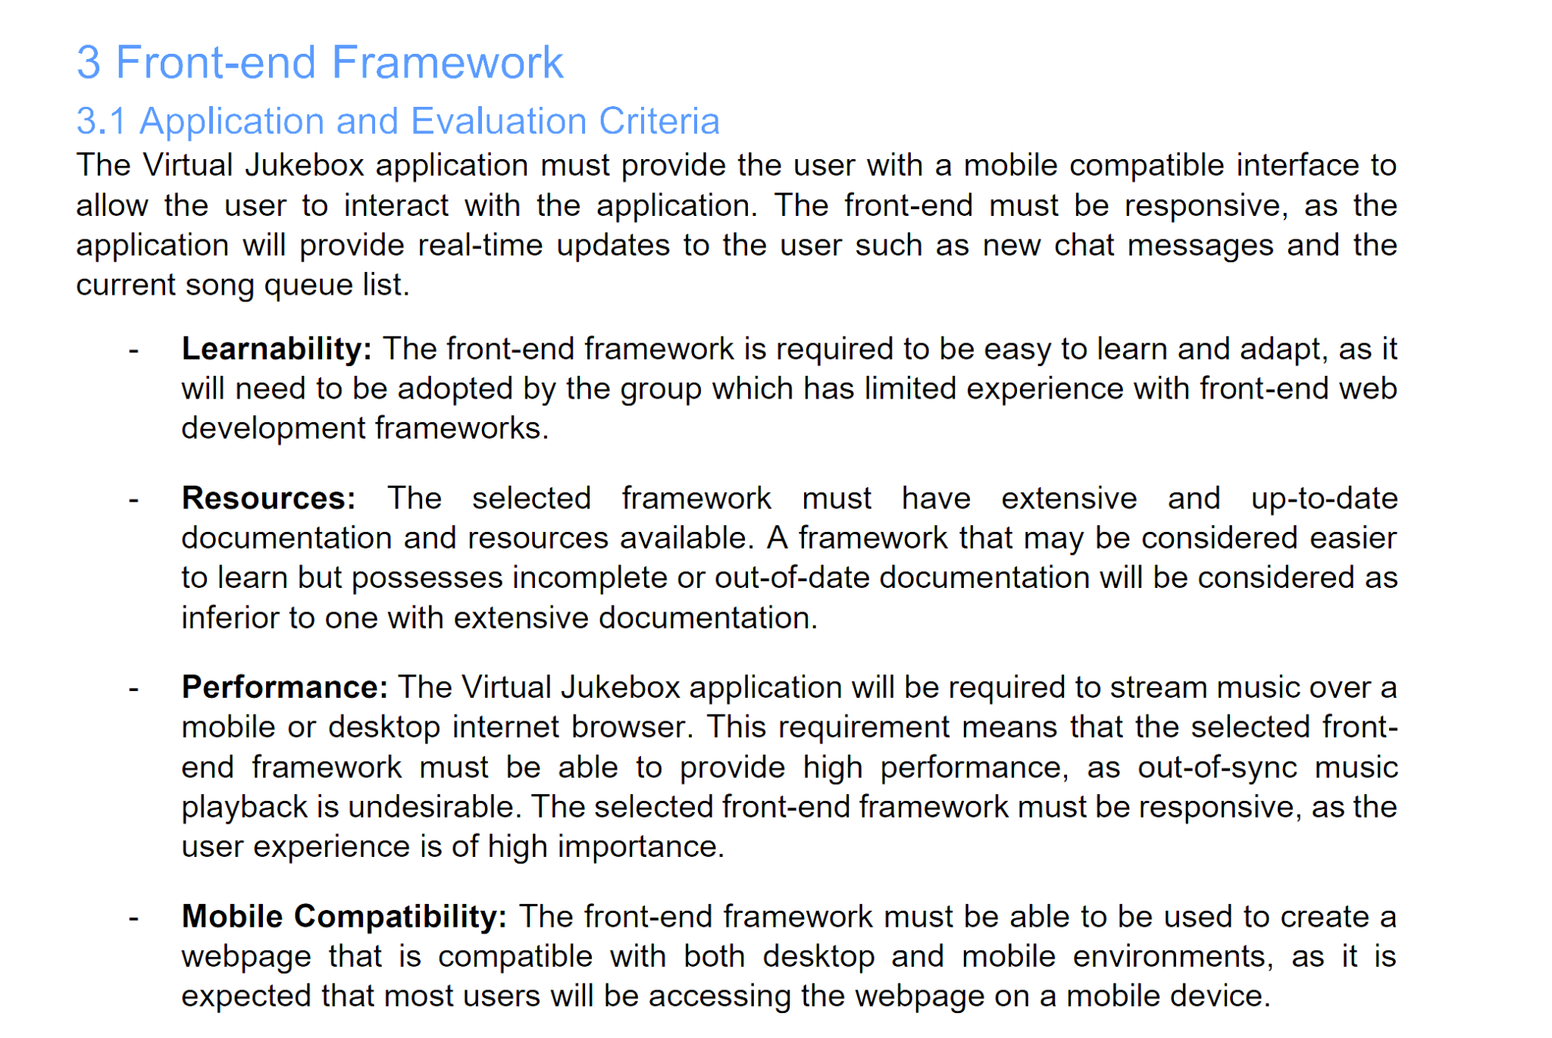

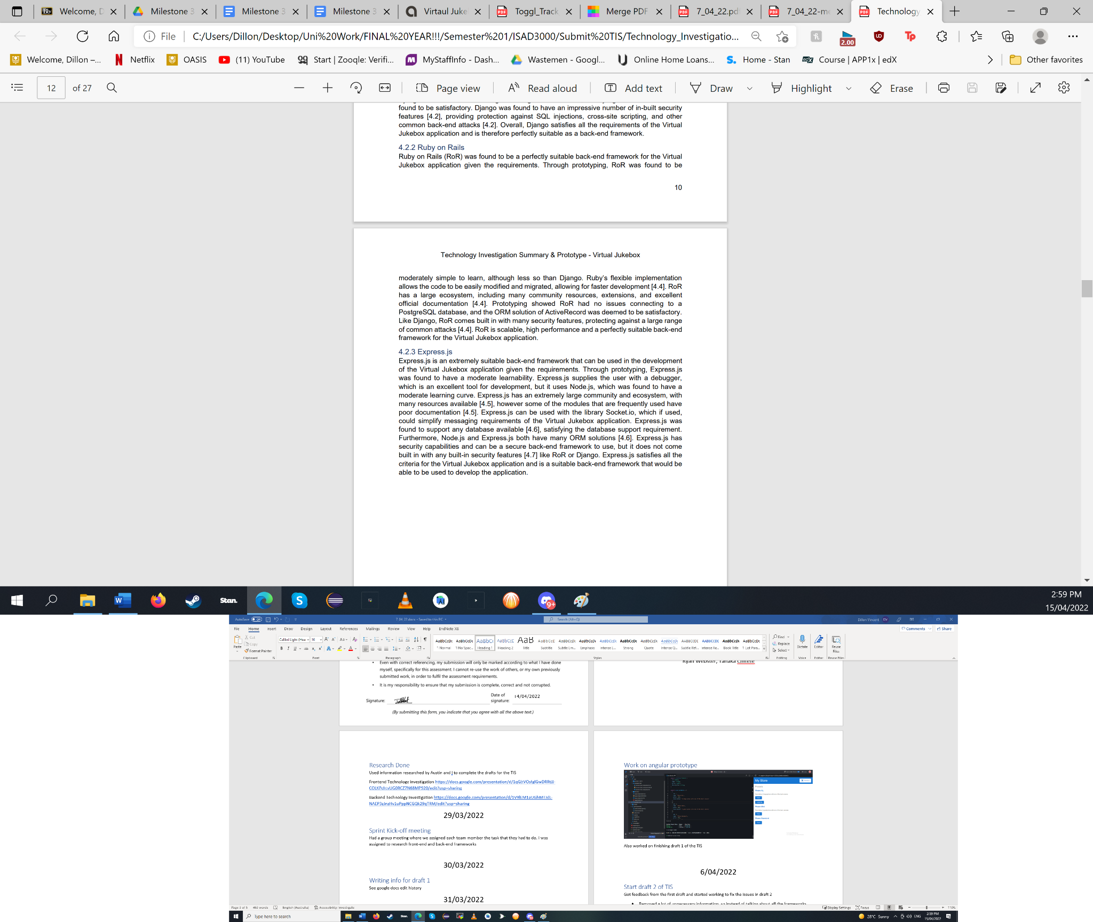

* + Did some referencing for section 3 and 4
  + see google docs for what has been done
    - Draft 1 - <https://docs.google.com/document/d/1qz_cY-77BbiIZ0fQX0lvMM7f0ywJyT2Y/edit?usp=sharing&ouid=100131243715973446500&rtpof=true&sd=true>
    - Draft 2 - <https://docs.google.com/document/d/1BpNhboGLjUXhomlX5YhedVEahl7ERE5D/edit?usp=sharing&ouid=100131243715973446500&rtpof=true&sd=true>
    - Final Submission - <https://docs.google.com/document/d/1hnBtiuO2KsugEbwM52fdL8kvcNOyucH-/edit?usp=sharing&ouid=100131243715973446500&rtpof=true&sd=true>
  + Created an angular prototype

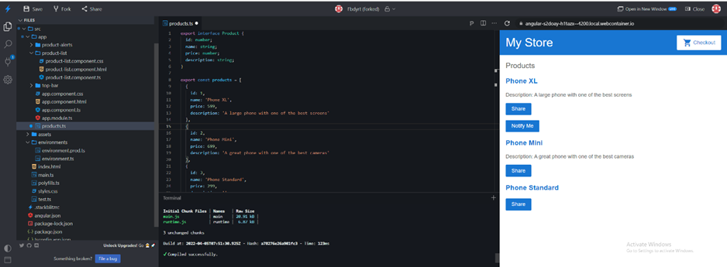

* *Ryan Webster:*
  + Researched what is required for implementing an instant messaging system for a web application. Compared pre-made solutions with technologies that can be used to create a chatting system from scratch.
  + Created an instant messaging prototype using the WebSocket API with a React.js front-end and Node.js back-end. Code can be found at: <https://github.com/ryan-webster/chat-react-node-socketio>
  + Decided on manual implementation of a chatting system utilising the WebSocket API on the client side of the application rather than using any ready-made solutions.
  + Proof-read and modified parts of the technical investigation summary to make language more consistent.
  + Submitted final copy of the Technical Investigation Summary and progress report to Amristar.
* *Tanaka Chitete:*
  + Researched requirements for implementing music streaming in the Virtual Jukebox application
  + In addition, read legal documentation outlining permitted usage for each SDK–all of which are limited to non-commercial, personal use only
  + Discussed with Amristar to clarify that the Virtual Jukebox application be used only in personal contexts (e.g. family gatherings, house parties etc).
  + Contributed to the Music Streaming SDK section of the Technology Investigation Summary. See the below screenshots for evidence of contributions:

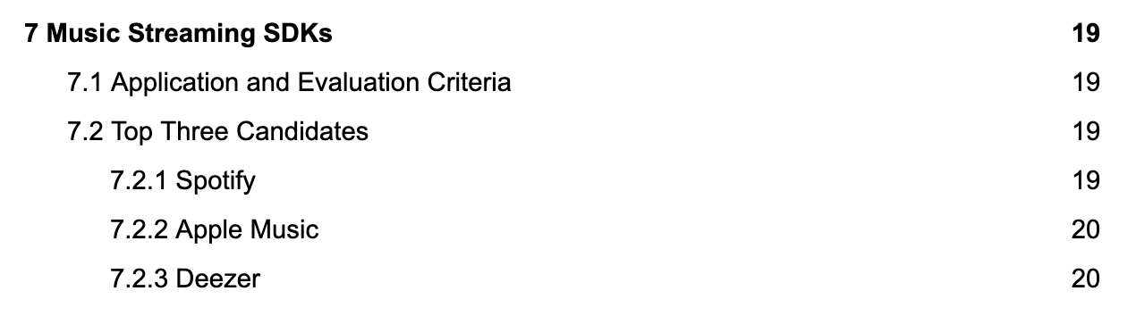

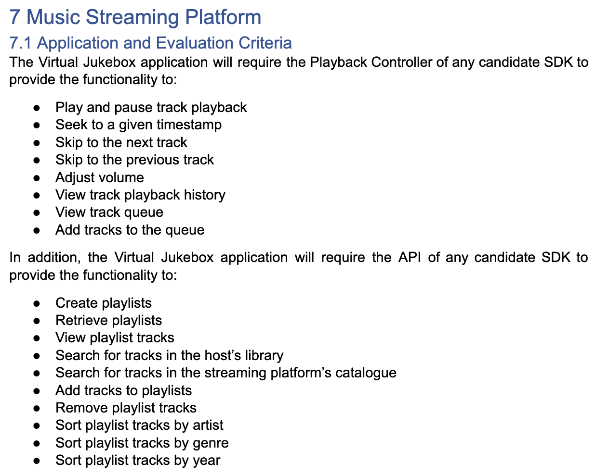

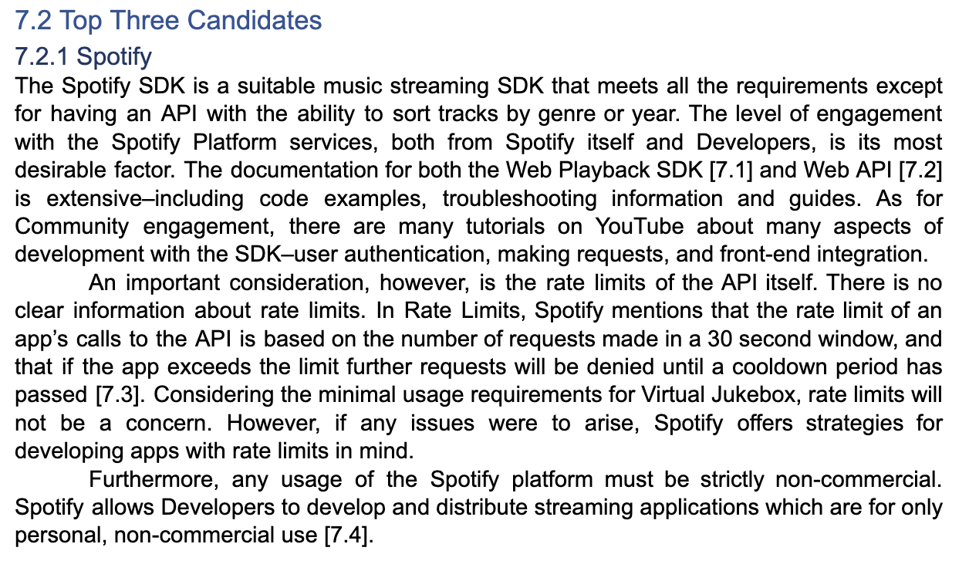

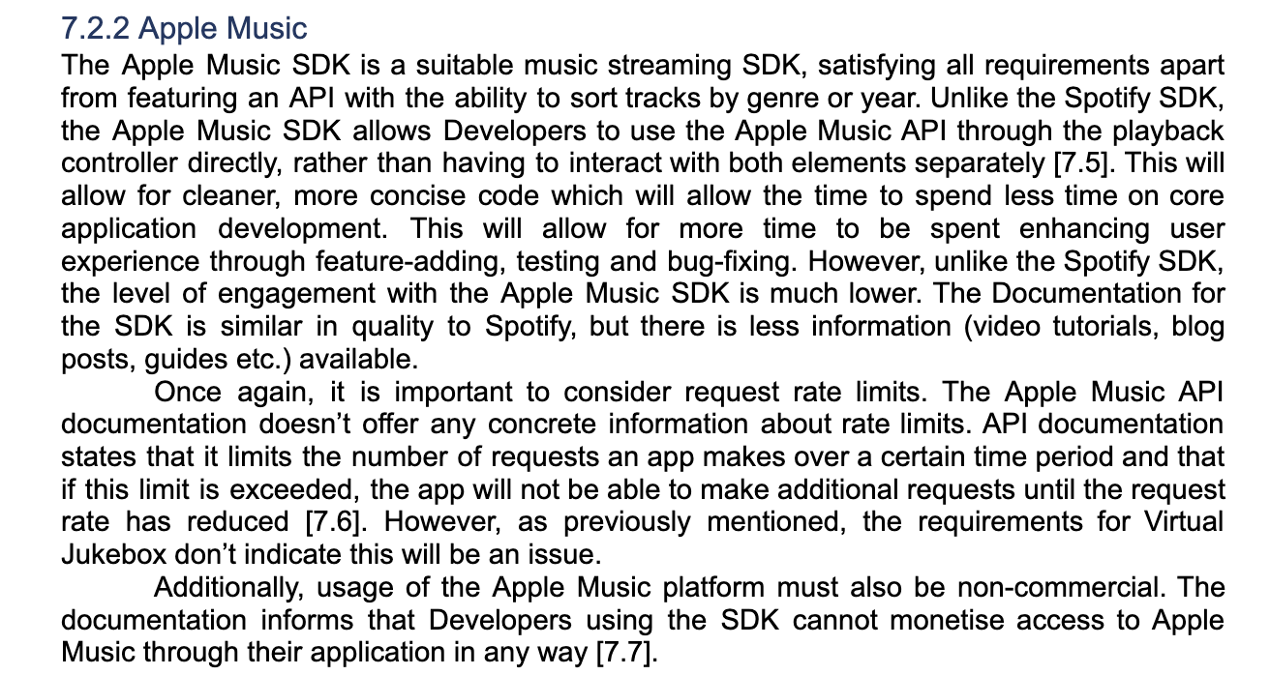

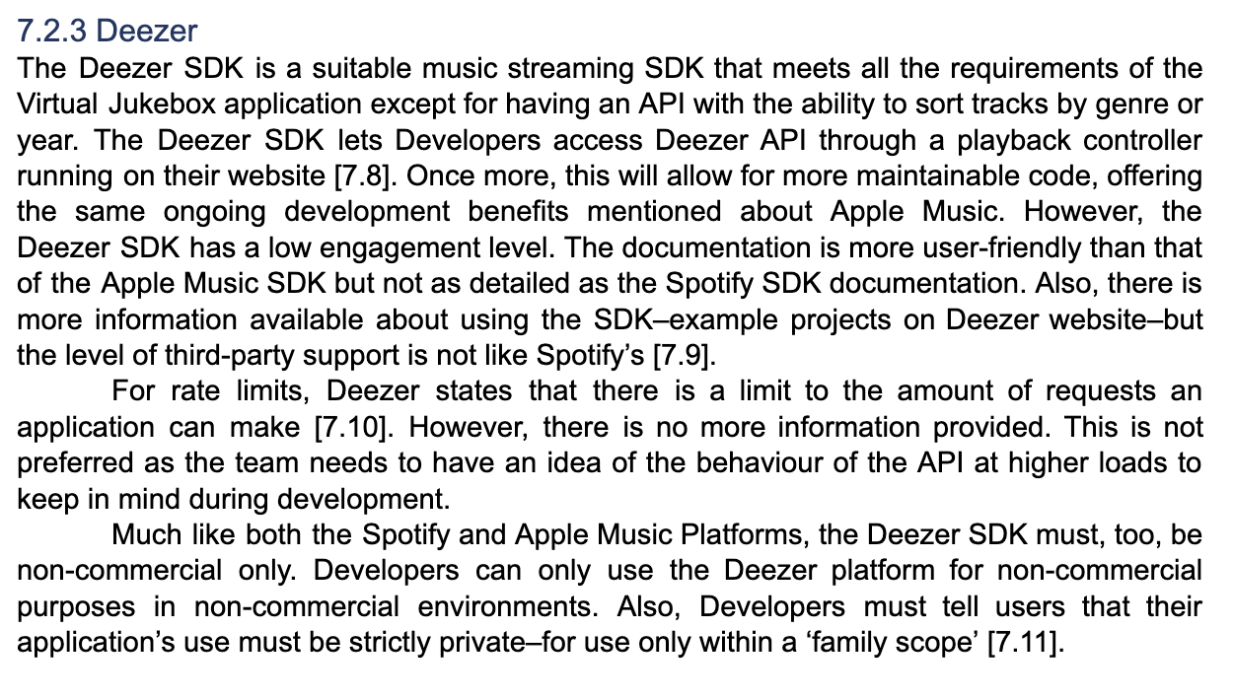

* + In draft 1 of the TIS, compared four streaming SDKs–Spotify, Apple Music, Deezer and Soundcloud
  + Upon more closely considering the requirements of the application, narrowed alternatives down to three SDKs–Spotify, Apple Music and Deezer
  + Ultimately, decided Spotify was the most ideal candidate–the level of engagement from both Spotify Developers (documentation, support etc) and also hobbyist developers (blogs, tutorials etc) was vastly superior to both Apple Music and Deezer.

Before the final TIS submission, the team proof-read the entire document together and made incremental changes to fix grammatical, content and formatting mistakes. Amristar had provided detailed feedback on each draft submission, which enabled a more refined final submission.

### Sprint 3

Sprint 3 has recently begun (12/04/2022), and will be the only sprint up until the final submission of the SRS deliverable due to the inability to split the deliverable into two 2-week sprints (less time than previous deliverable). It will involve the submission of three documents to Amristar, including:

* Software Requirements Specification (SRS): Includes outlining the non-functional and functional requirements of the final product, including categorising them into required, preferred and optional (importance). Use-cases and actors will also need to be described in relation to the software.
* Project plan: Using Microsoft Project, the team will define tasks with dependencies and estimates for the completion of the final product.
  + Licenses have been assigned to both Austin and Bradley, but completion will require whole-team contribution.
* Progress report: Team and individual contributions for the reporting period, and any issues with the project.

The backlog at this current time for the sprint (as shown in JIRA) is: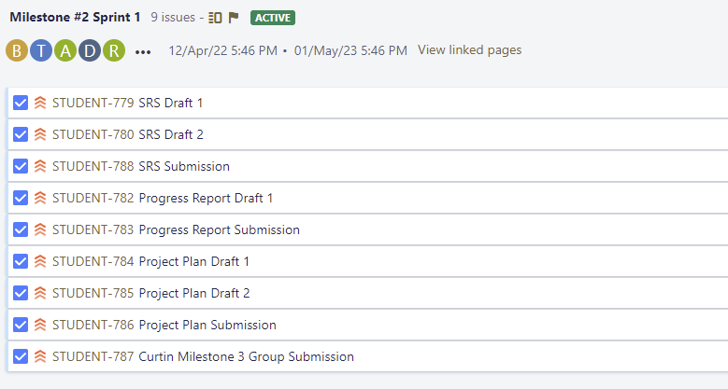

The current active sprint (3) is assigned as follows (includes effort estimates):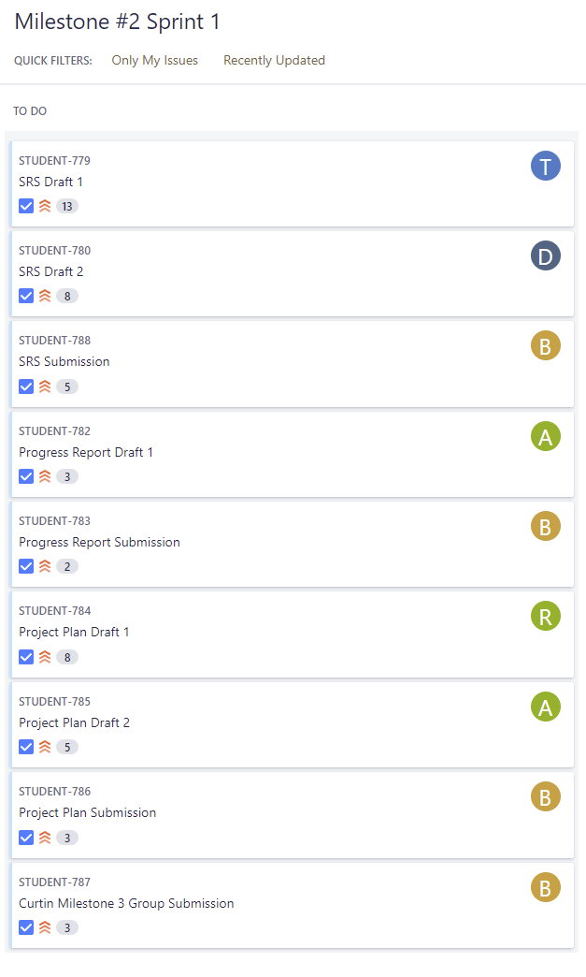

As sprint 3 has only recently begun (12/04/2022), not much has been achieved as of yet, however, JIRA tasks were assigned regarding the Software Requirements Specification deliverable, in addition to the Project Plan and Progress Report required for submission. Specific allocation of tasks per member have not yet been decided on due to the nature of a software requirement specification requiring a large amount of collaboration to decide on which functional/non-functional requirements the final product will need, should have, and those that are optional.

## Reflection

Each group member has been present in every major meeting so far, with only a few absent in a couple stand-up meetings. No major issues have been present throughout each sprint so far except for time constraints which will be increased in the current and next sprint due to assignments being released in other units. It would have been beneficial to submit the first TIS draft by the end of sprint 1 to give more time for refinements based on feedback, but it wasn’t overly important as it was instead submitted early in sprint 2. Overall, sprint 2 was successful as the final TIS and progress report deliverable was submitted on time (as well as two separate drafts of the TIS), however, some improvements could be made. Possible changes include submitting a progress report draft before its final submission, as well as team collaboration in document formatting and compilation in early stages, to avoid needing to reformat content and report layouts. The second deliverable (SRS and Project Plan) is currently on-track for completion by the given due date (1/05/2022).

## Group Toggl Summaries

Below showcases individual group member’s time spent as per Toggl throughout the reporting period. See individual report submissions for time break-downs per task.

**Austin Bevacqua**

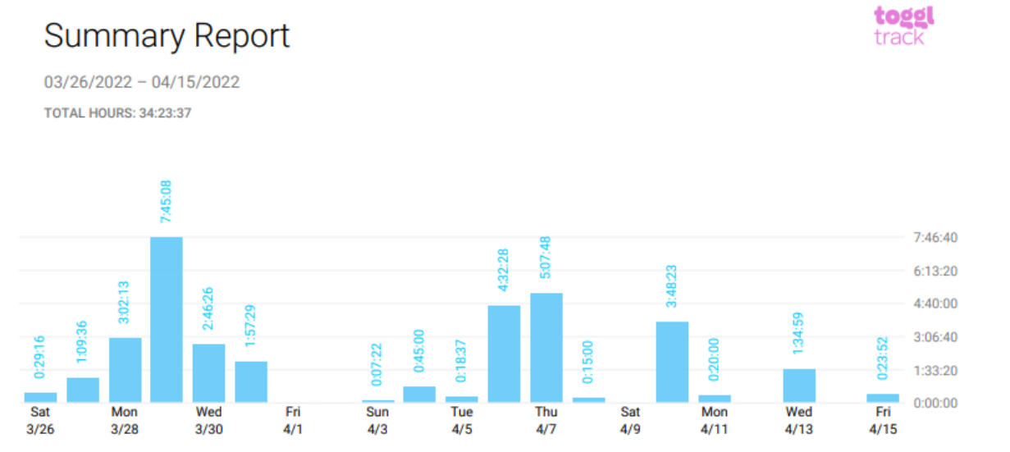

**Bradley van der Zwan**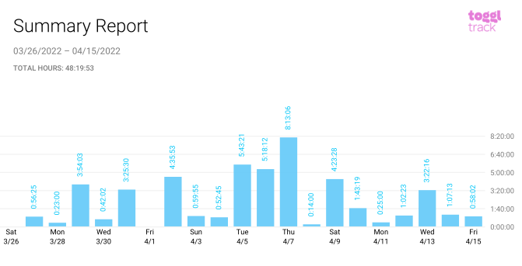

**Dillon Vincent**

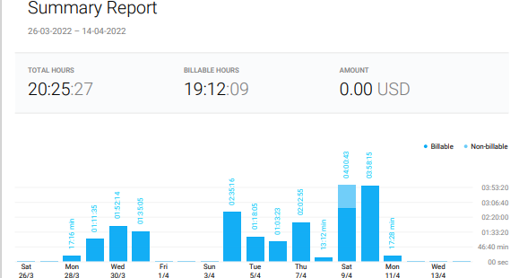

**Ryan Webster**

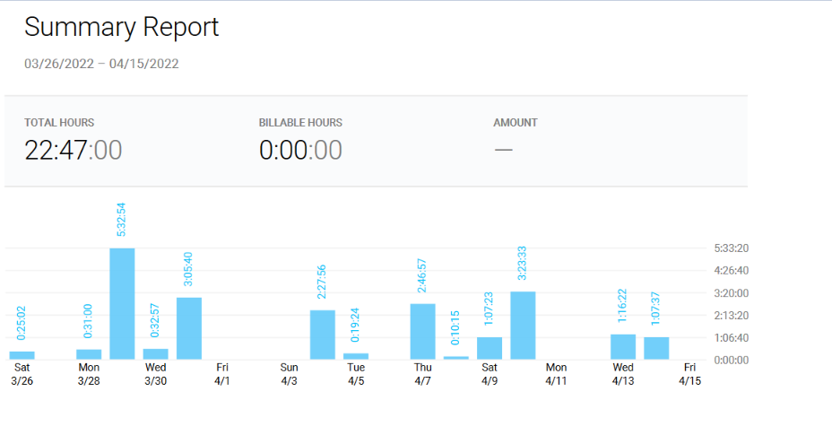

**Tanaka Chitete**

